DEPLOYEMENT OF APP IN IBM CLOUD – DEPLOY IN KUBERNETS CLUSTER

Date | 8 Nov 2022
Team ID | PNT2022TMID34668
Project Name | Nutrition Assistant Application

- Open IBM Kubernetes Service.
- Select the Region where you want to deploy the cluster, type in a name for your cluster, then click Create Cluster.
- Select the appropriate cluster type depending on your account. • It takes some time for the cluster to get ready (around 30 minutes).

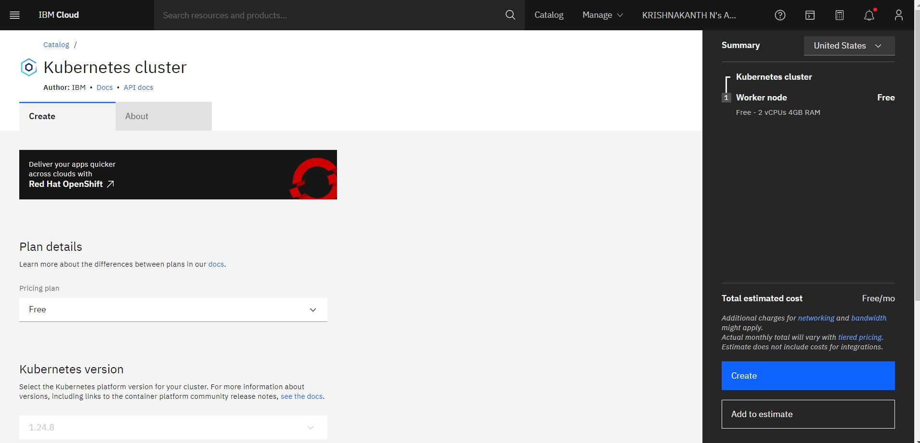

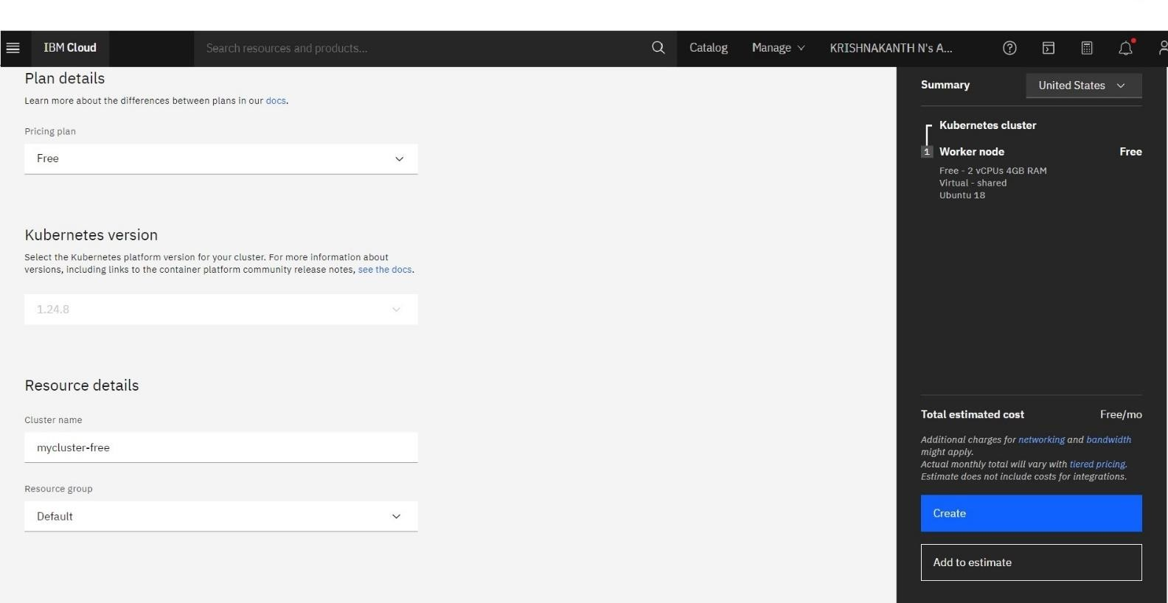

Once the cluster is ready, click on your cluster's name and you will be redirected to a new page with information about your cluster and worker node.

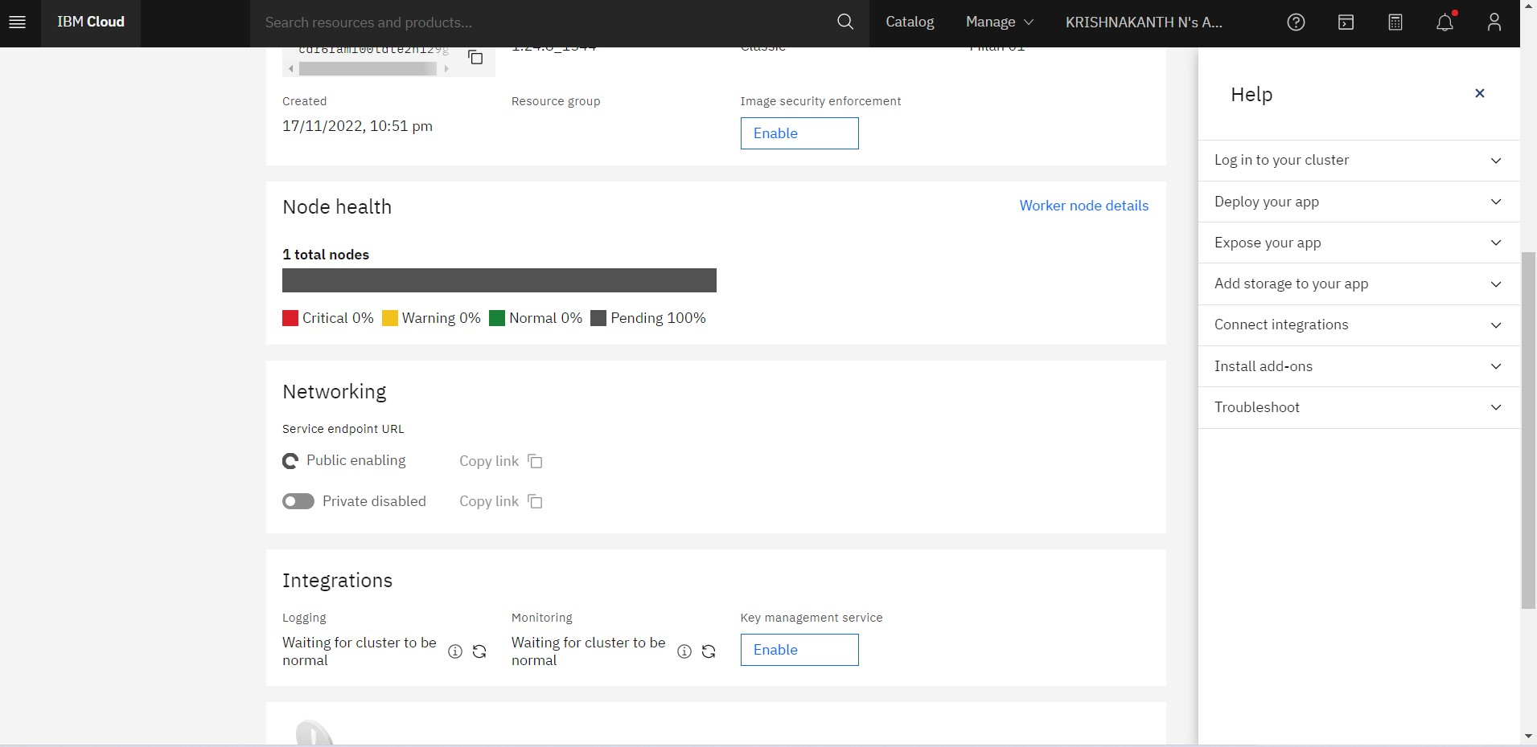

- Click on the Worker Nodes tab to note the cluster's Public IP.
